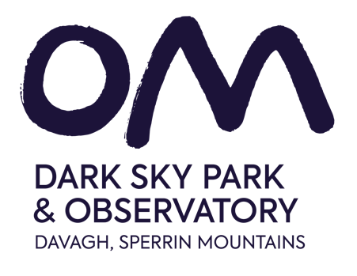

A Visual Story

For Your Visit to OM Dark Sky Park and Observatory

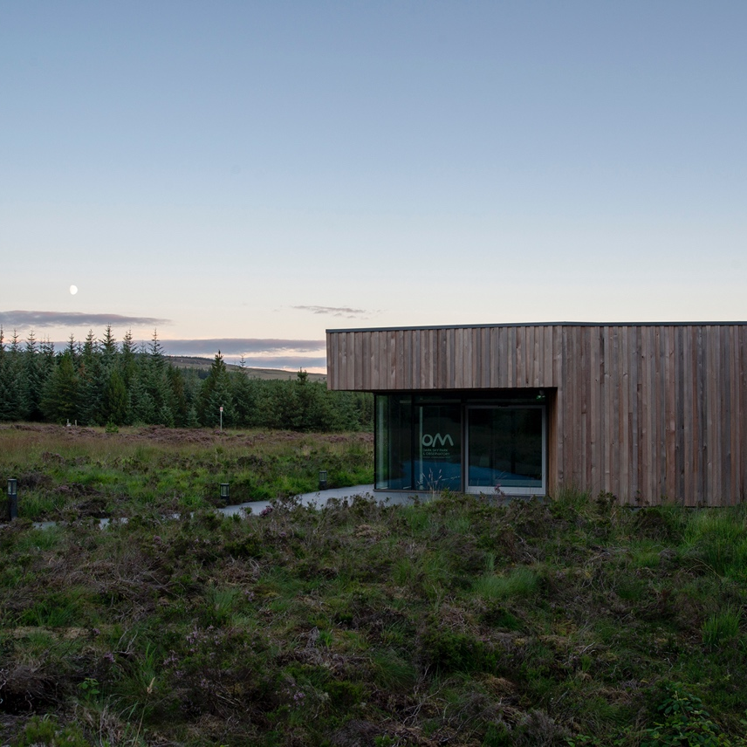

Car Parking

On arrival to Davagh Forest travel through the first car park and drive along the forest road. You will arrive in the second car park. The OM building is located on the right-hand side of the second car park. There are four accessible parking bays which are nearest the pathway to the building.

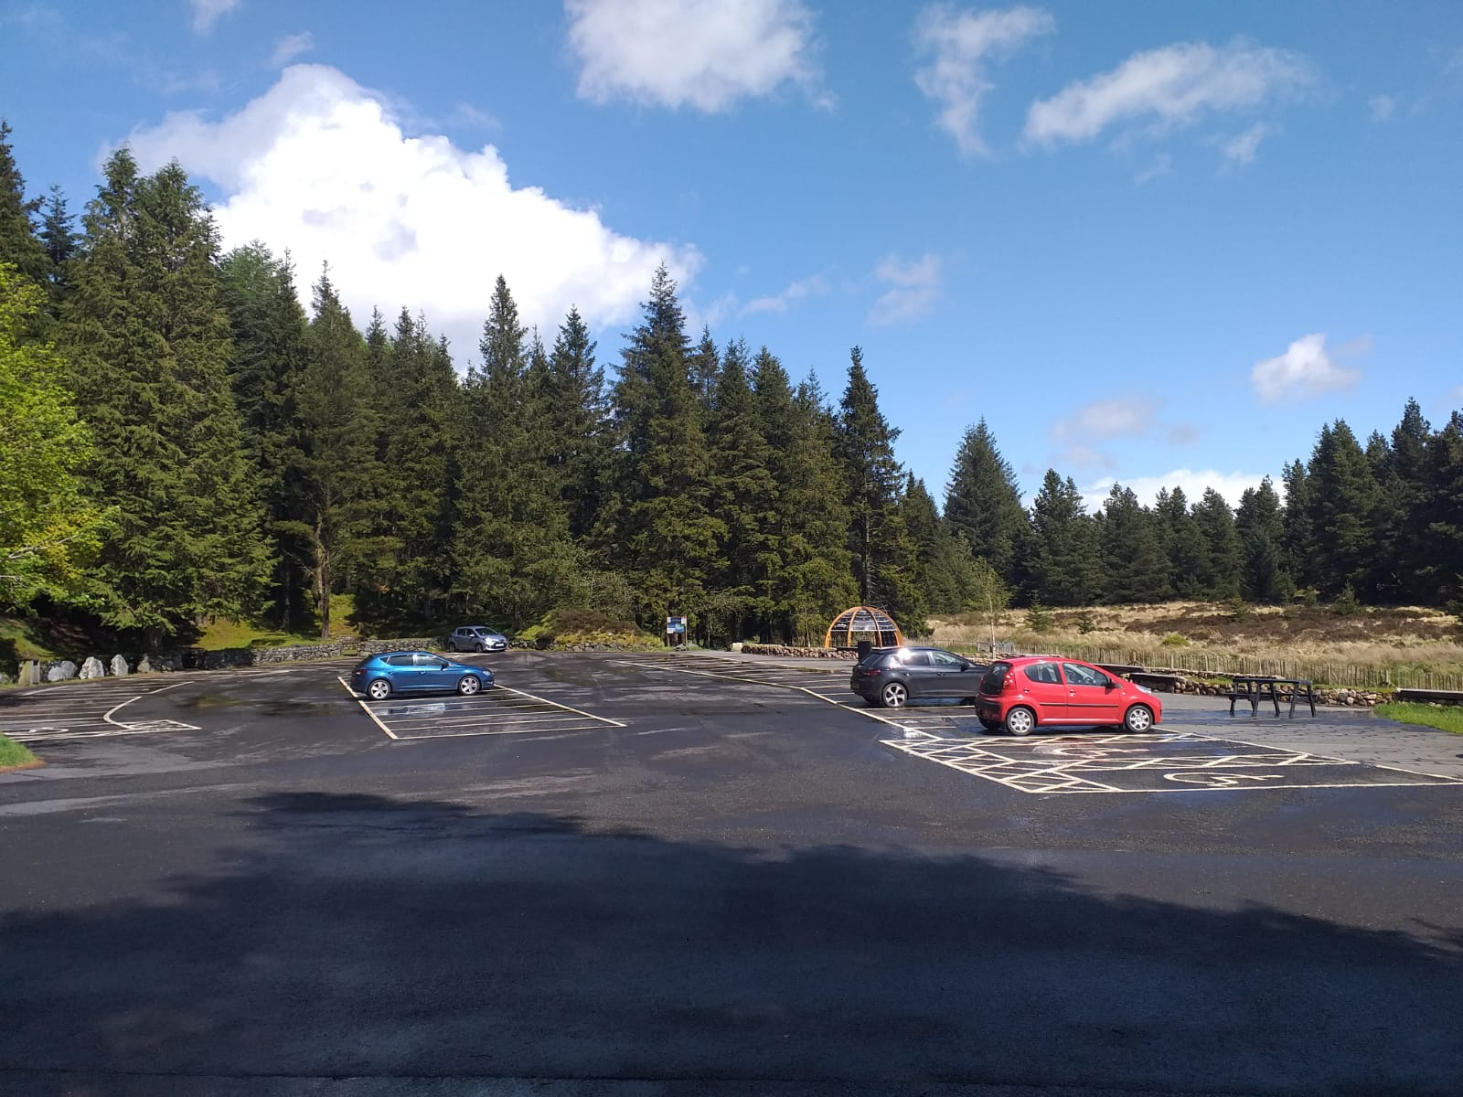

Walking or getting to the building

The OM building is visible from the car park, it is a short walk over the bridge on a flat wooden boardwalk into the building. There are two sets of automatic doors into the building.

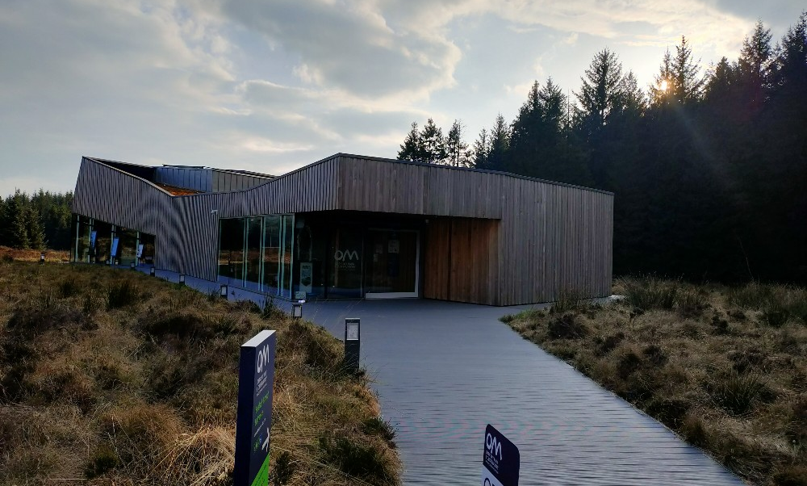
Entering the building

When you arrive at the front of the building there two sets of automatic doors which will open for you. When you walk through the second door there is a small seating area, you can sit here for a short rest if you need to.

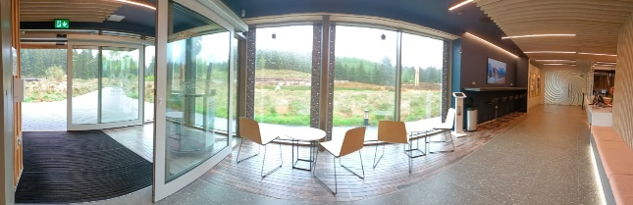

Toilet Facilities

Toilet facilities are located on the right-hand side when you enter the building. There are both male and female toilets.

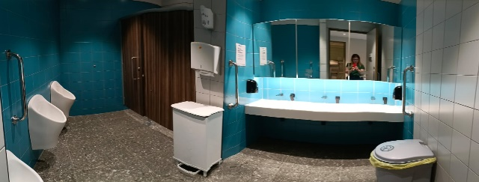

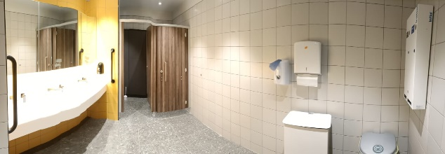
Changing Places

There are changing places facilities should you have any additional toilet or changing needs. They are wheelchair accessible with plenty of space for you.

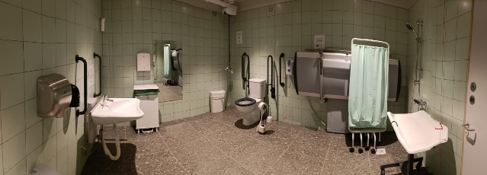

Reception Desk

When you arrive at the reception desk there may be some people waiting. You might have to wait in a small queue, but it won’t take long. The reception desk is where you check in or pay for your guided tour. You can also pay for items at reception from our grab & go food station or items from the gift shop.

If I need any help I can ask a member of staff at the reception desk, they wear navy and green uniforms with a name badge.

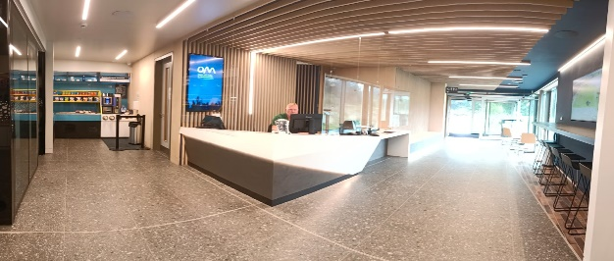

Grab and Go Area

We have a Grab & Go area located at the side of the reception desk where you can purchase hot or cold drinks, refreshments, and snacks. If you need help, ask a member of our staff at the reception desk who will be happy to help you. If you want to purchase something from here, take it to the reception desk where you can pay with cash or card.

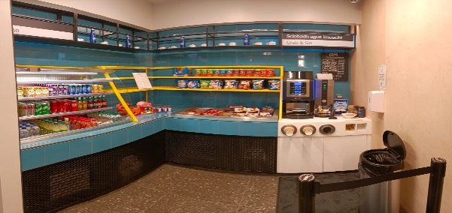

Gift Shop

The Gift Shop is located opposite the reception desk where you can buy a souvenir. If you would like any help to pick or get a gift you can ask a member of our staff at the reception desk to help you. You can pay for any gifts you purchase at the reception desk.

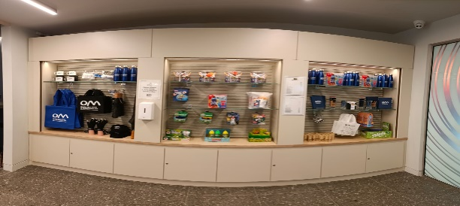

Guided tours

If you have booked a guided tour your tour will start in front of the glass doors. You will be accompanied by a tour guide though the doors to the start of the exhibition. A tour guide will be always with you.

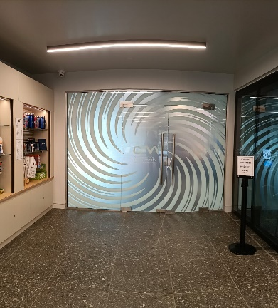

The Exhibition Area

Guided tours take place in the Exhibition Area, there are visual displays, bincoculars and seats in this area.

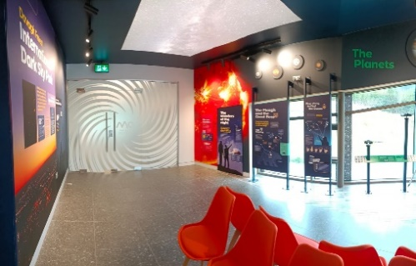

There are also videos and telescopes that visitors can interact with.

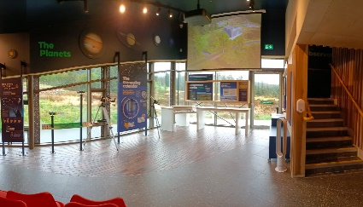

We have virtual reality headsets which you can use on the guided tour. If you would like to try these and need help, please ask the tour guide to assist you.

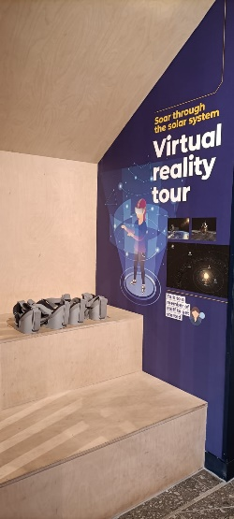

Stairs to the Observatory and Telescope

There are stairs up to the first floor of the building. These stairs take you up to the observatory to see our telescope.

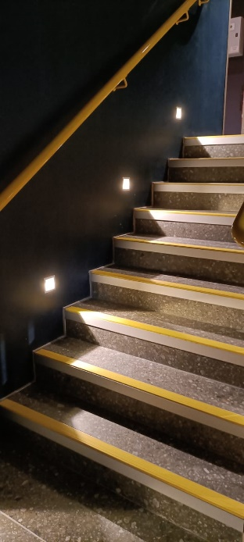

Lift to the first floor.

There is also a lift if you cannot use the stairs.

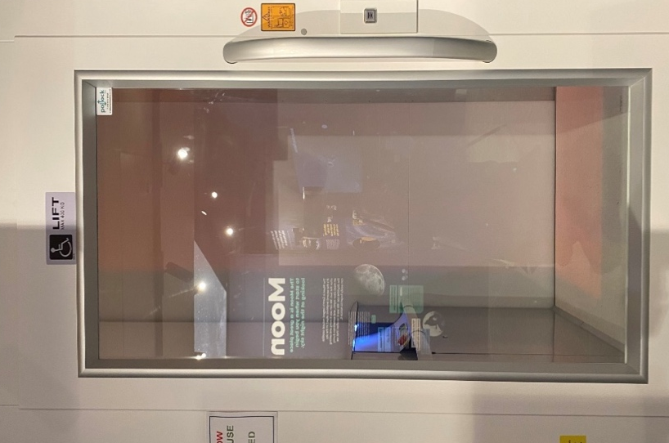
The Observatory and Telescope

There is a door at the top of the stairs. This will take you into the Observatory where the telescope is. There are red lights in this room, so you can see the stars better. The roof may be open if the weather is good so you can see the sky.

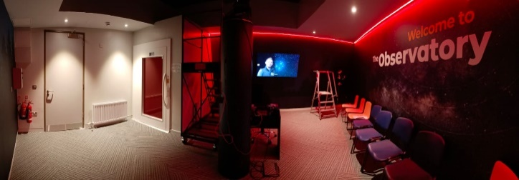

The tour guide will tell you when the tour has ended. You can ask the guide questions about your visit.

Leaving the building

When your visit has ended you can leave the building in the same way you came in – past the reception desk and out through the automatic doors at the front.

More information

If you require more information or assistance when visiting you can contact us by phone on 028 8676 0681 or by email omdarksky@midulstercouncil.org

We look forward to welcoming you to OM.

